**ANJALI BHATT**

Phone No: 8595823563

E-mail:bhattanjali2001@gmail.com

LinkedIn Id: <https://www.linkedin.com/in/anjalibhatt30>

DOB: 30-12-2002

LinkedIn Id:



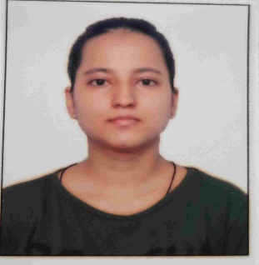

**CAREER OBJECTIVE**

A hardworking and self-motivated fresher to establish a successful career in the field of lingustic field, problem-solving abilities, and passion for innovation. I aim to contribute to an organization’s growth by utilizing my knowledge for the success of the company. I strive to continuously learn and stay updated with the latest industry trends and advancement to enhance my expertise and deliver exceptional result.

ddkd

**EDUCATIONAL QUALIFICATION**

|  |  |  |
| --- | --- | --- |
| **QUALIFICATION** | **YEAR** | **BOARD/UNIVERSITY** |
|  |  |  |
| **Bachelors of science (BSC)** | Result Awaited | IGNOU |
| **Intermediate** | 2017-2018 | CBSE, New Delhi, D.S.R Modern School |
| **High School** | 2019-2020 | CBSE, New Delhi, D.S.R Modern School |

**PROFESSIONAL QUALIFICATIONS**

* Basic Japanese (JLPT N5), TENSAI INSTITUTE OF JAPANESE LANGUAGE.
* Intermediate Japanese –I (JLPT N4), TENSAI INSTITUTE OF JAPANESE LANGUAGE.
* Intermediate Japanese –II (JLPT N3), TENSAI INSTITUTE OF JAPANESE LANGUAGE.

**LANGUAGES**

SKILLS & ATTRIBUTES

* English(Fluent)
* Hindi(Native)
* Japanese(Intermediate)

**SKILLS & STRENGTH**

SKILLS & ATTRIBUTES

**SKILLS**

* MS Excel
* MS Word
* MS PowerPoint

**STRENGTH**

* Interpersonal skills
* Teamwork
* Patient listener
* Fast learner



**HOBBIES**

SKILLS & ATTRIBUTES

* Art & Craft
* Listening to music

**PERSONAL DETAILS**

**Address: Village-Chaura,Sector-22 Noida**

**Pin code: -201301**

**PLACE: Noida, India**